**Name: Sushant Tulasi**

**Class: D15B**

**Roll: 64**

**Adv DevOps Assignment 2**

# Terraform Deployment using FDP on AWS S3 Bucket

## 1. Install and Configure Terraform

Ensure that Terraform is installed on your local machine. Configure AWS CLI with your access key and secret key by running:  
```  
aws configure  
```  
Provide your AWS credentials (Access Key ID, Secret Access Key, region, and output format).

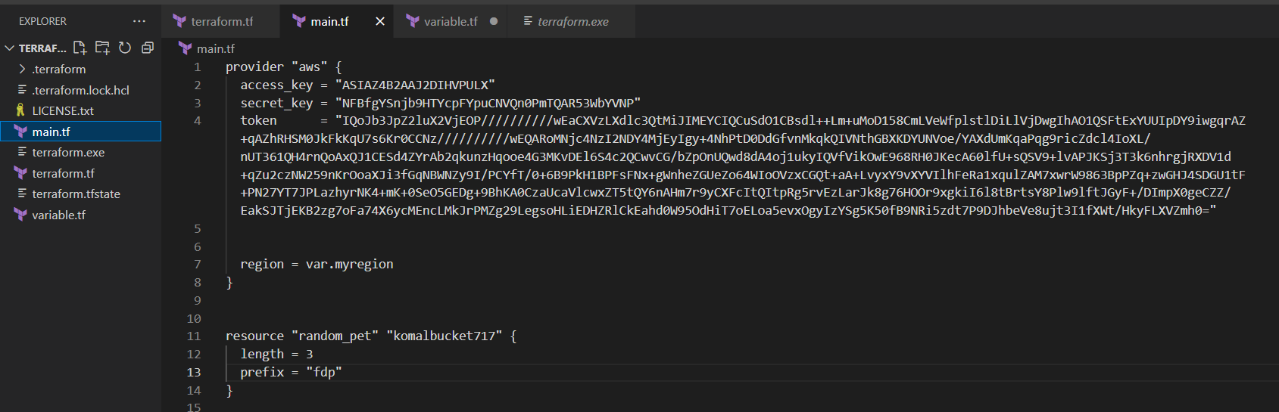

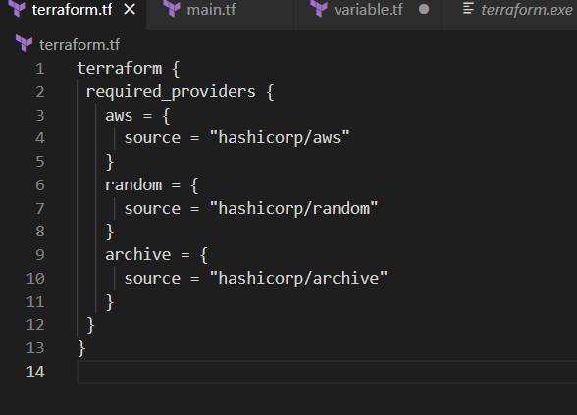

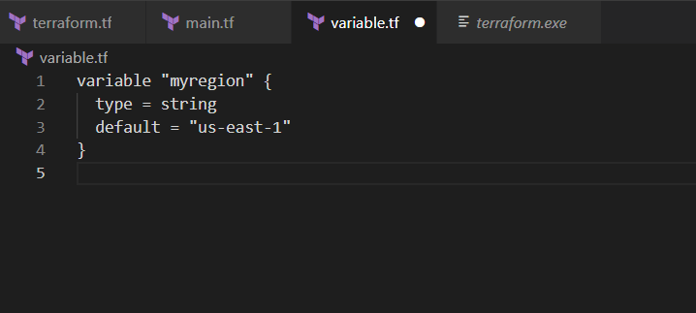

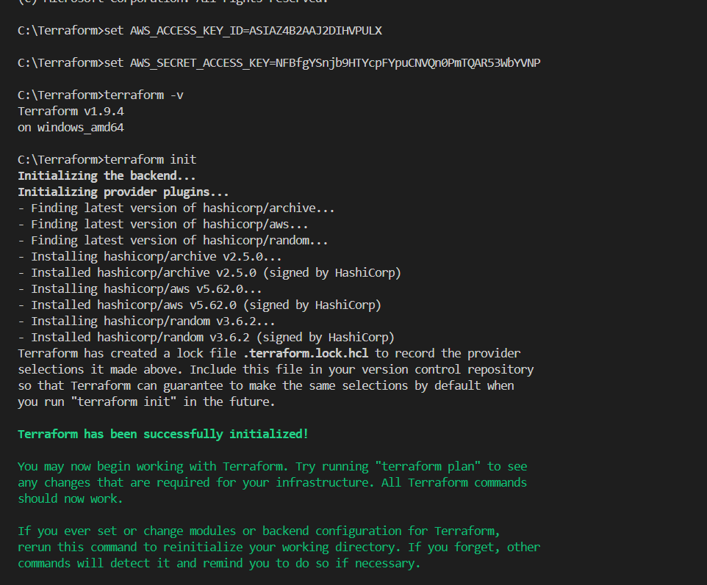

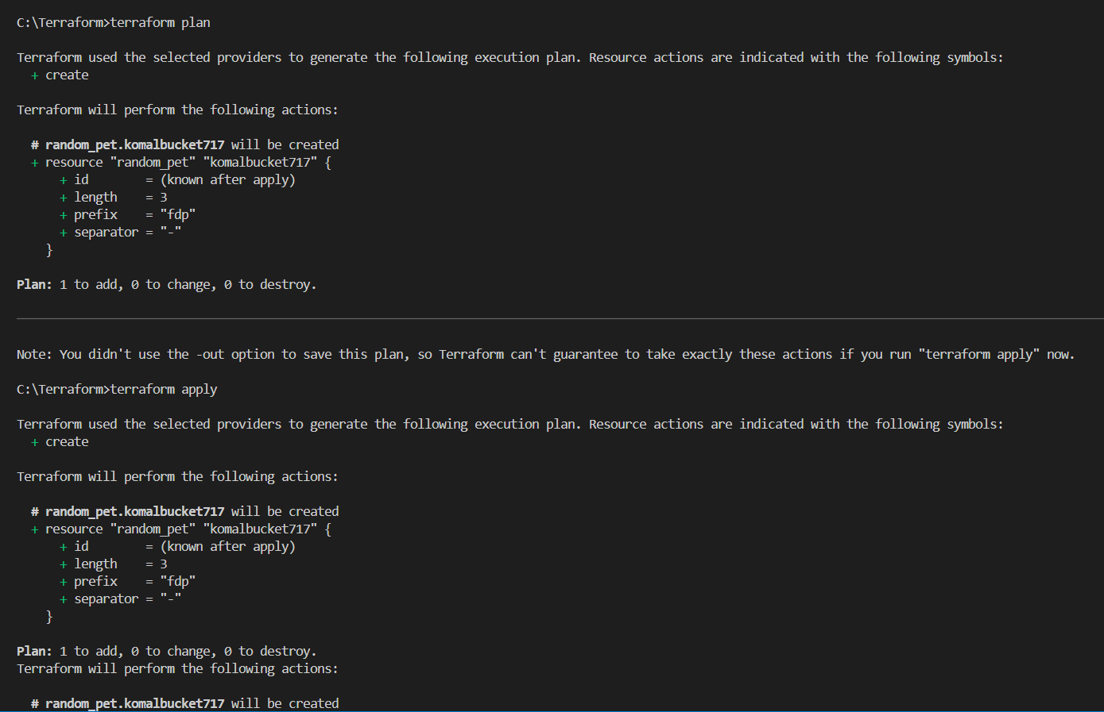

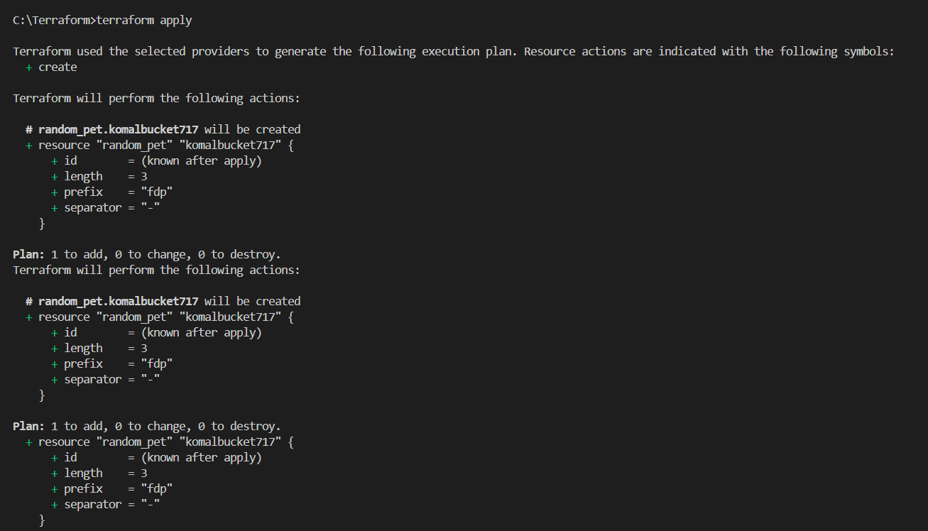

## 2. Create the Terraform Configuration Files

Create a new directory for your Terraform configuration files. Inside the directory, create a file named `main.tf` with the following content:  
```  
provider "aws" {  
 region = "us-east-1" # or your preferred region  
}  
  
resource "aws_s3_bucket" "my_bucket" {  
 bucket = "my-unique-bucket-name"  
 acl = "private"  
}  
  
output "bucket_name" {  
 value = aws_s3_bucket.my_bucket.bucket  
}

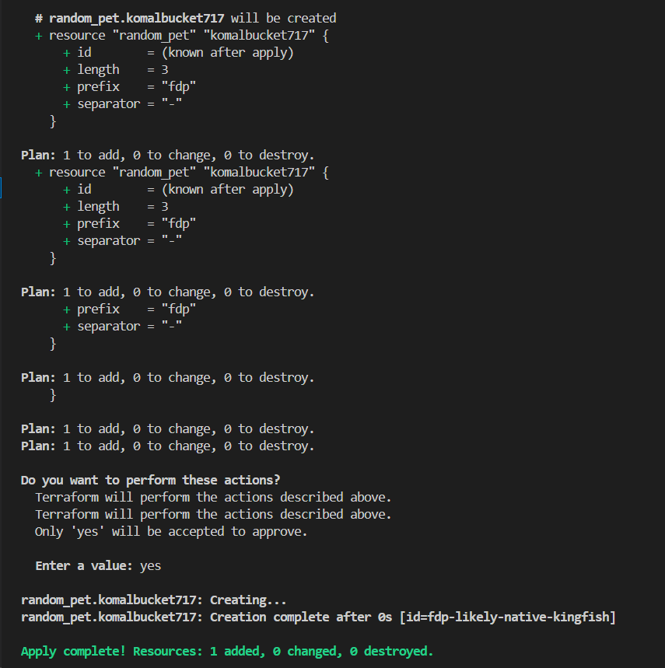

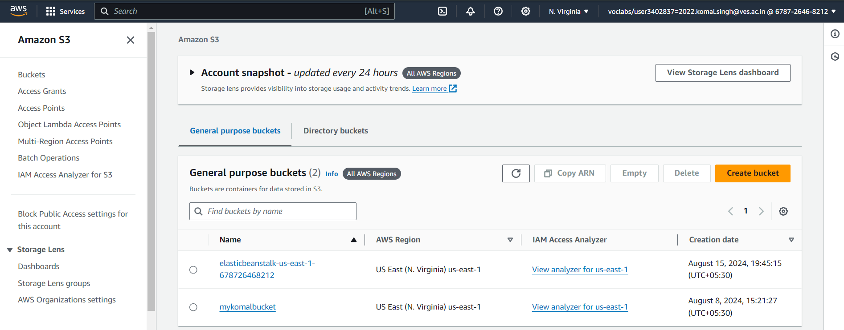

## 3. Initialize Terraform

Run the following command in your terminal to initialize the Terraform working directory:  
```  
terraform init  
```  
This step downloads the required provider plugins.

## 4. Format and Validate the Configuration

Format your configuration files using:  
```  
terraform fmt  
```  
Validate your configuration to catch syntax errors:

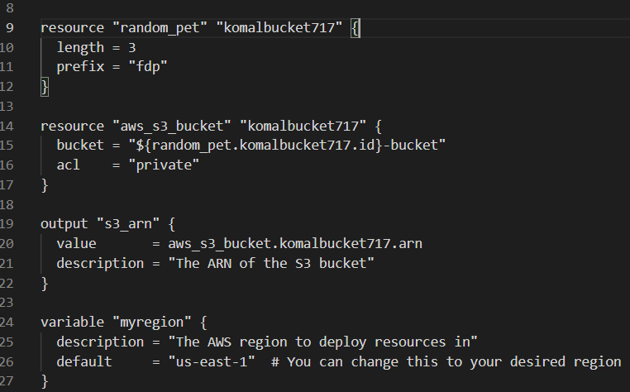

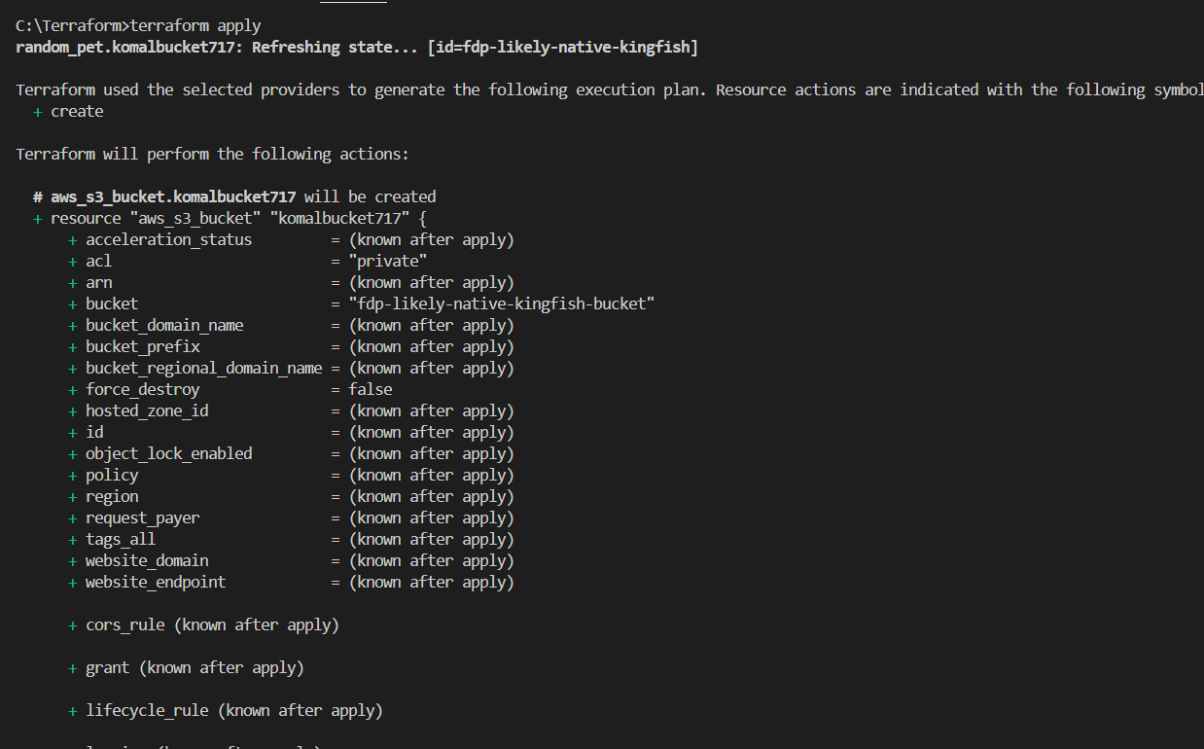

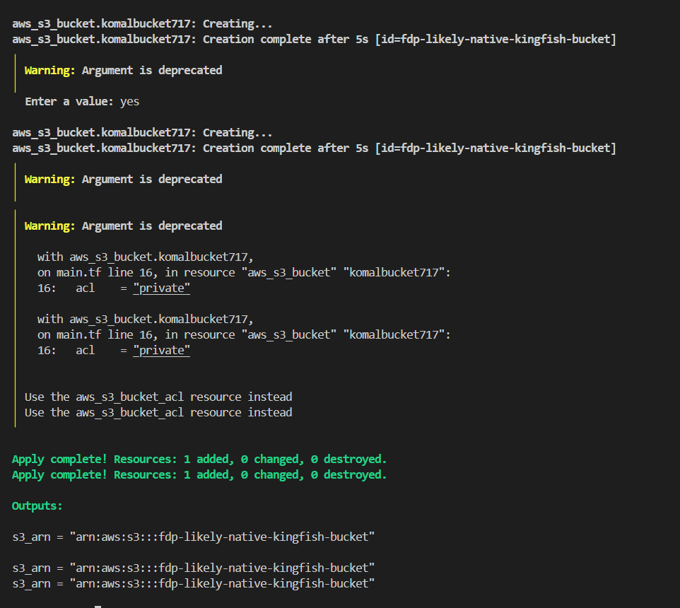

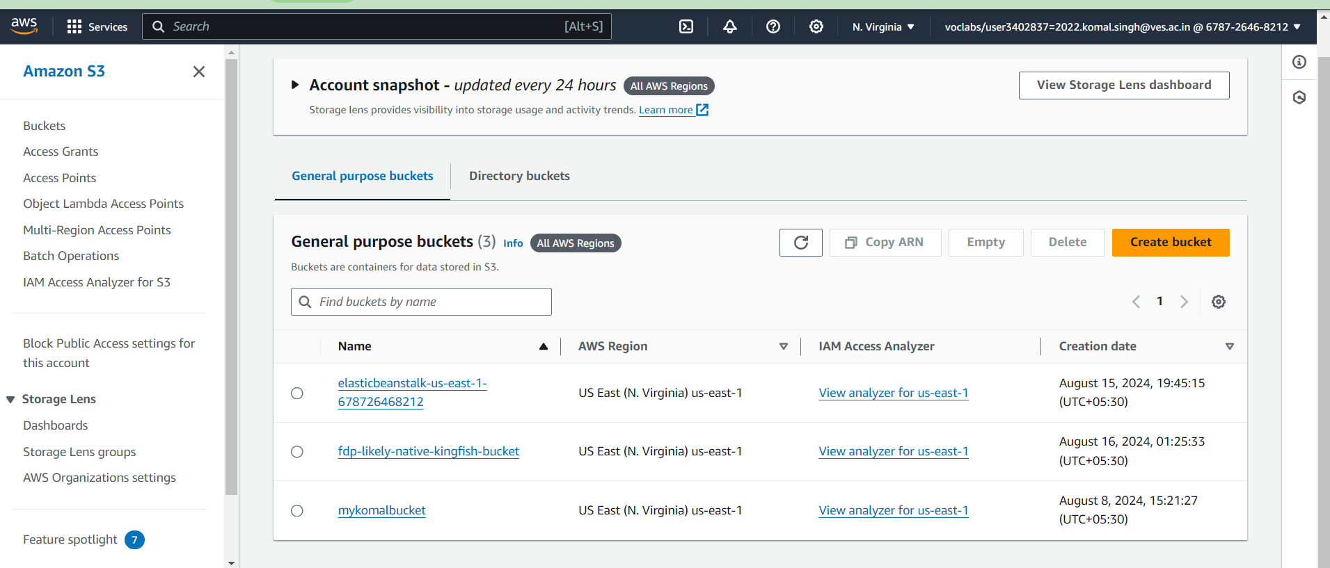

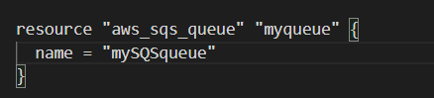

## 5. Plan the Deployment

Use the following command to create an execution plan:  
```  
terraform plan  
```  
Review the plan to ensure that Terraform will create your S3 bucket as intended.

## 6. Apply the Terraform Configuration

Deploy the infrastructure by running:  
```  
terraform apply  
```  
When prompted, type `yes` to confirm the deployment. Terraform will create the S3 bucket as specified in your configuration.

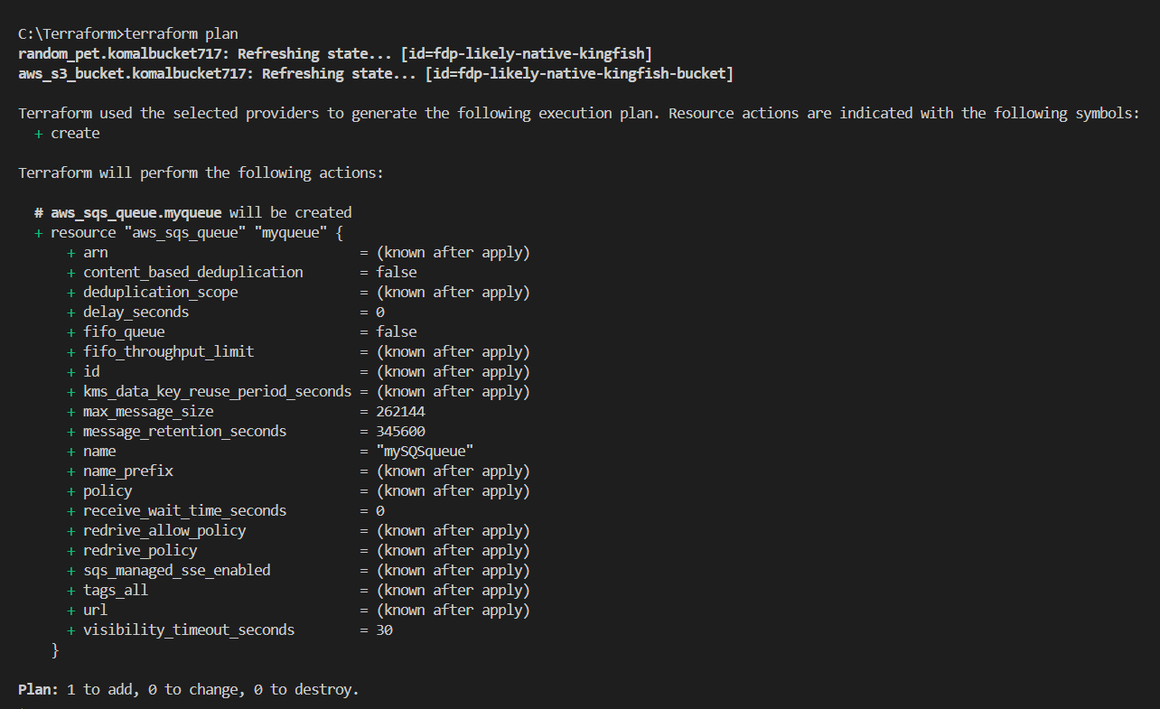

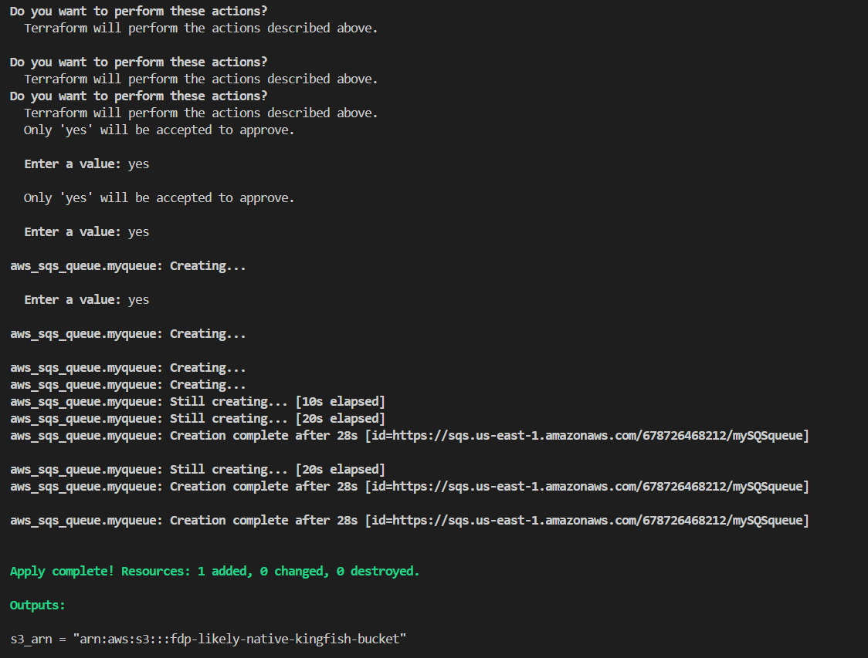

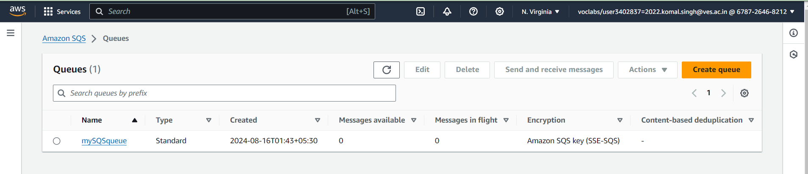

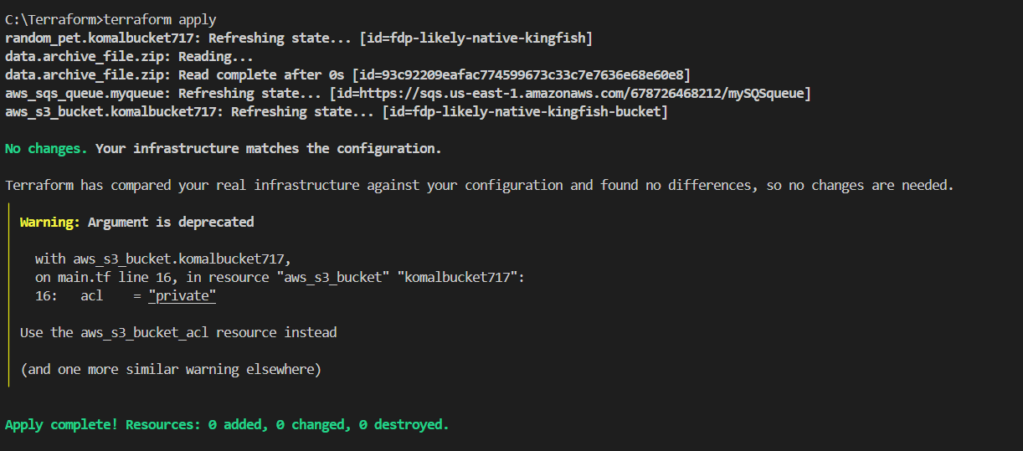

## 7. Verify the Deployment

Go to the AWS S3 console and check if the bucket has been created successfully. You can also verify by listing the buckets using the AWS CLI:  
```  
aws s3 ls  
```

## 8. File Delivery Platform (FDP) Integration

If your File Delivery Platform involves uploading files to S3, configure the FDP to point to the bucket created by Terraform. Use the AWS SDK or CLI commands to manage file uploads from the FDP to your S3 bucket.

## 9. Upload Files Using FDP

Ensure that your FDP is configured with the correct AWS credentials and permissions. Upload the required files to your S3 bucket using FDP's interface or automation tools.

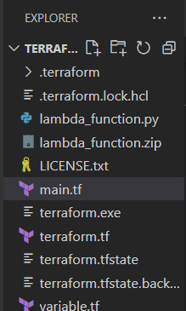

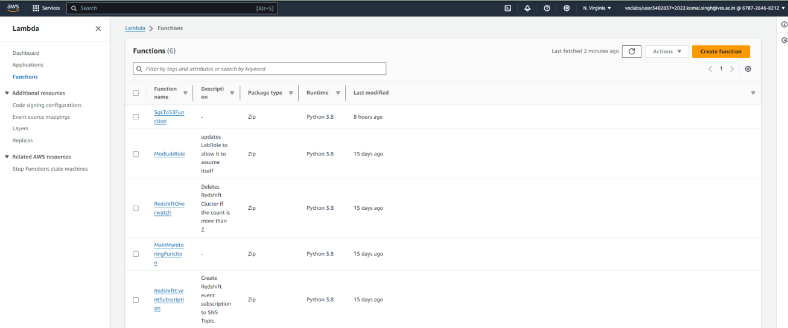

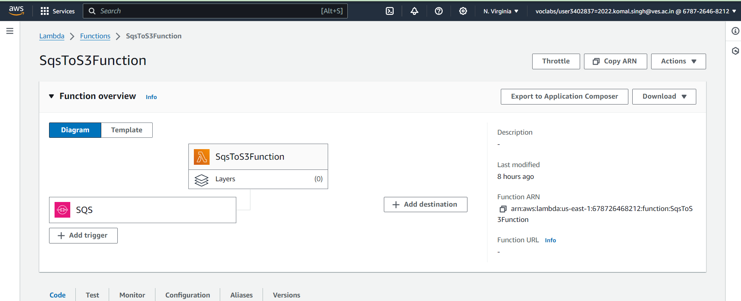

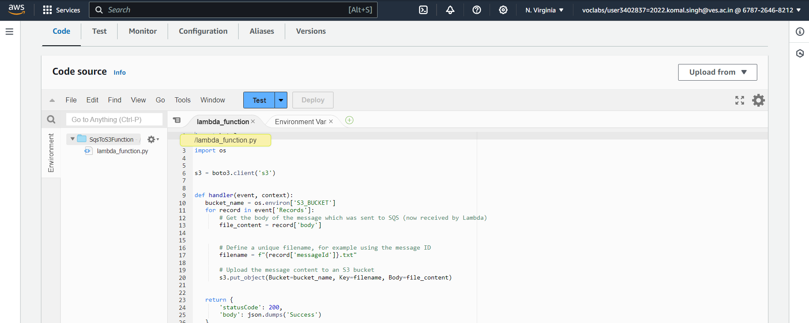

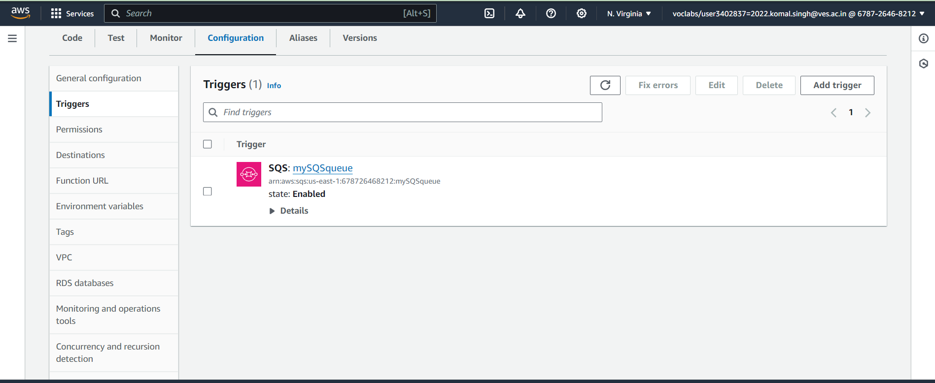

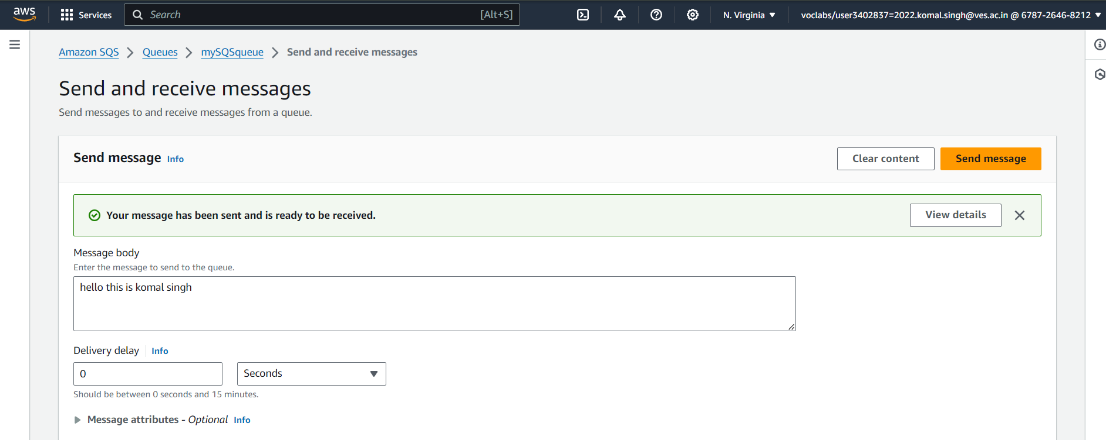

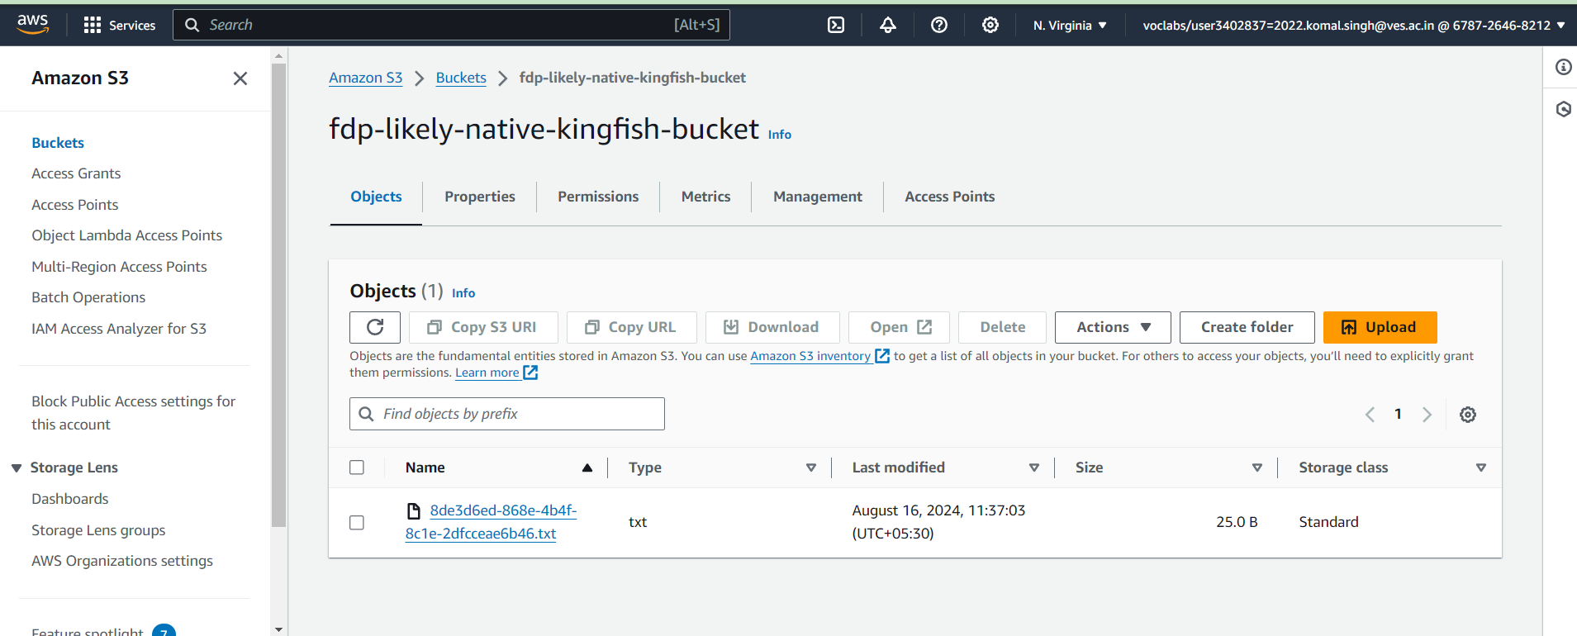

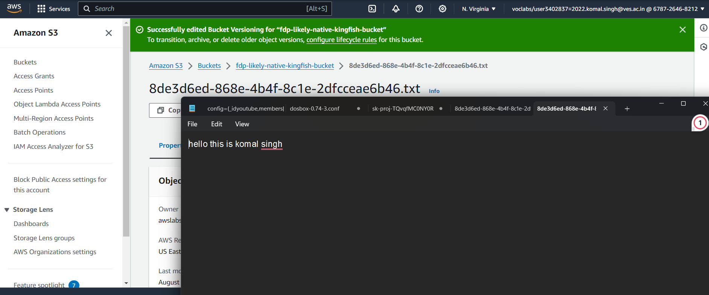

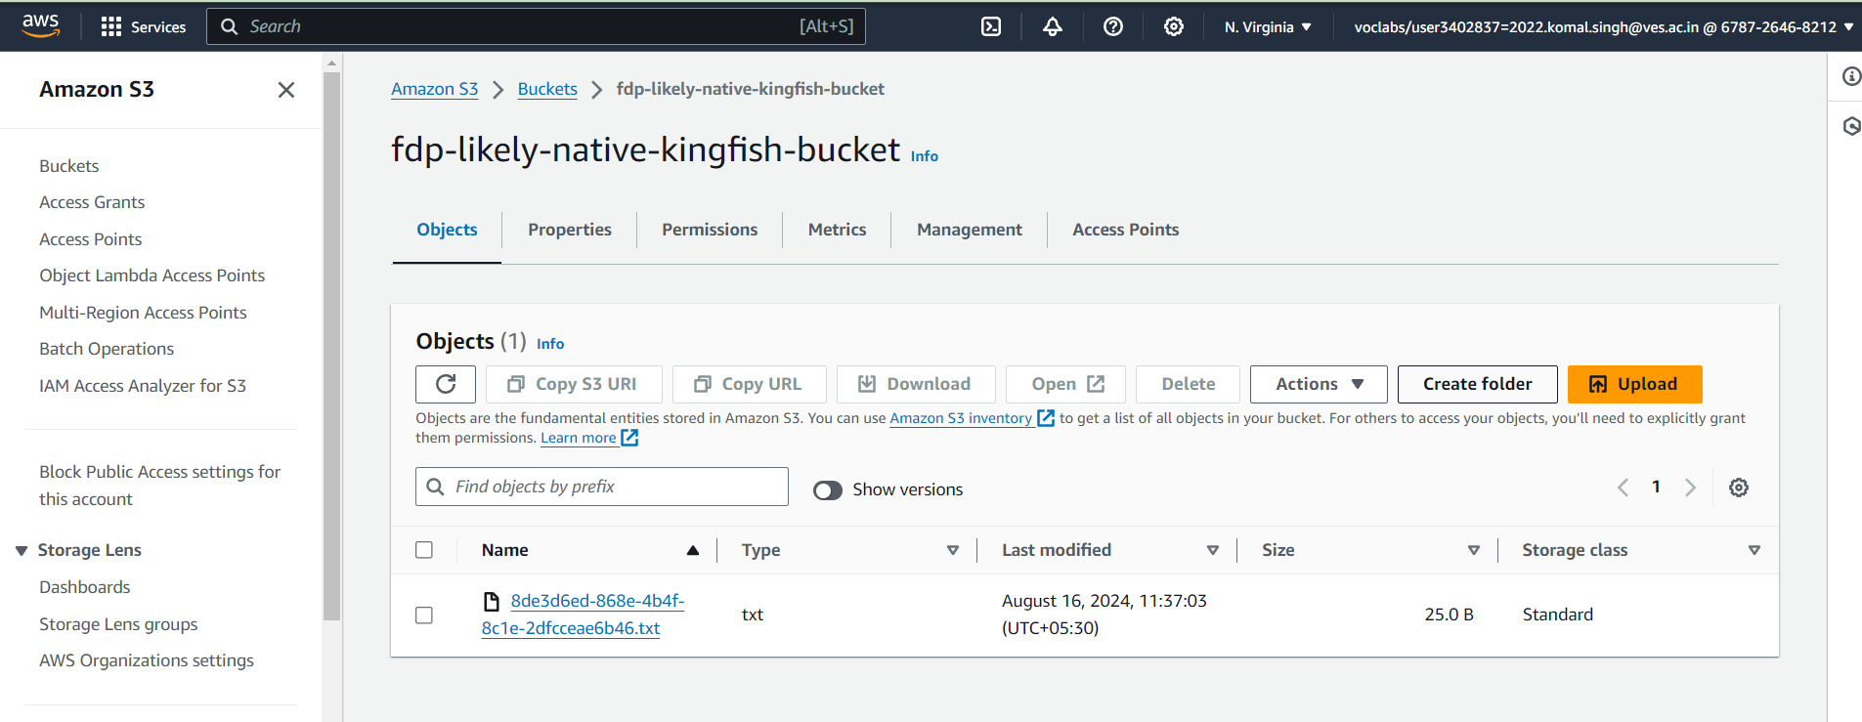

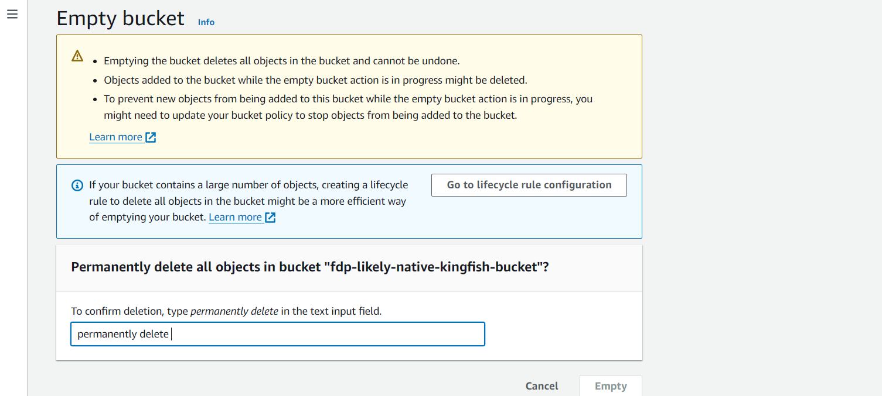

## 10. Clean Up Resources

Once you're done with testing or using the resources, you can destroy the infrastructure using:  
```  
terraform destroy  
```  
Type `yes` to confirm the deletion of the S3 bucket and other associated resources.

